Dr. Surendra Kumar
Population &Economic Development
Population growth plays a conflicting role in the development process of a country. It helps economic development and it retards economic development.
Economic development is one of the most debatable topic on earth. There are a lot of theories which show that rise in population has negative effect on both economic growth and development of a country. All these debates have started since Malthus proposed his theory in the book “Essay on the
Principle of Population”. He tried to find out the reason for diminishing returns in most of
countries and he said that Population growth is the major reason. His theory goes in as follows:-

- Population increases by compounding.
- Food production doesnot get compounded.
- The new population will not get sufficient amount of food.
Some adverse event ( starvation, crisis etc) causes decline in the population. Then this leads to food production & population coming back to equilibrium.
There are generally three different types of views on how population effects the economic development of a nation. One, opposing the positive impact on economic development. Two, supporting the negative effect of economic development. Three, they believe that there is no relation between economic development and population growth. Malthusian Population Trap is the main example for the theories which support negative impact. There are a few other theories which support the positive impact stating the importance of human capital on economic development in a country. This also rises from the fact that any growth in the economic development needs human capital as its main weapon and the rise in population can act as a provider of human capital. According to this view population growth is the real strength and power of a country. They also say that with higher population, we will have high labor force and this will help for creating labor diversity in the nation and in turn will help for the rise in output of a nation.
But there is a possibility of other way around too. This population rise can be a disaster if we don’t us them properly. This is the major problem with most of the developing countries face. Both the stands of views present their arguments about population growth and economic development. Each of the views is supported both theoretically and empirically.
Indian Scenario
In India, the population has increased from 682.5 million in 1980 to 1259.695 million in 2015. Whereas the GDP in 1980 is 186 billion US Dollars and it has reached a new heights by getting almost close to 2 trillion dollars. Luckily in India, the rise in GDP has outsmarted the Population growth and this led to a positive progress in the country. But at the same time when we compare the
progress of our nation with the other nations which were in level with us 30 years ago, we did let ourselves down. Most of the studies state that the continuous increase in the population of the nation has led to the slow growth rate of nation. But they do agree that the increase in population has led to the variety in labor. This variety in labor also led to the overall increase in productivity of
the nation. So we just can’t blame the
population growth to be the main reason to slow the progress. If we compare ourselves with the China, they also had a huge population rise but they
are able to cope up with that and they created one of the top most economies in the world. The inefficiencies in the Government may be one of the reasons for slowing down the progress of our nation. So we considered the Corruption Perception Index as a variable in our model and we wish that this
will produce some good results. The low literacy rate may be one of the
reasons for the slow economic growth of our nation and at the same time the
unemployment in the nation also created a lot of chaos in the country. The government is unable to live up to the expectations and
they didn’t create enough employment opportunities in the nation. So we considered unemployment rate of the country as a variable. Many studies have shown that economic freedom of a nation plays a key role in the growth of output of a nation and also in the economic progress. India has consistently performed badly in terms of economic freedom and the inefficiencies in the centralized implementation of rsources made it worse. So this can also be one of the reasons for slow performance of our nation. So we considered the economic freedom index also as an variable in our model.

Poverty and Inequality:
Poverty and income inequality are the direct as well as indirect result of the above mentioned factors. Thus rapid population growth is one of the important problems of India. For the betterment of the economy, if the population growth must be slow.

Pressure on Natural Resources:
India was an agricultural nation for majority of the years in the past. The cultivable land and almost all other things depend on irrigation. Supply of both cultivable land and the water for agriculture became stagnant in India. But the population growth remained to be consistently high. So this increased the pressure on other factors too. Population pressures are alarming for arable
land, forests and water resources. The size of arable land has decreased due to
population pressure, inadequate arable land reforms and inheritance patterns. Before the mid of this century, India is projected to face a scarcity of cultivable land and other resources. The projections also state that in another 150 years, India will face the scarcity of electricity and this will also lead to chaos in the nation.
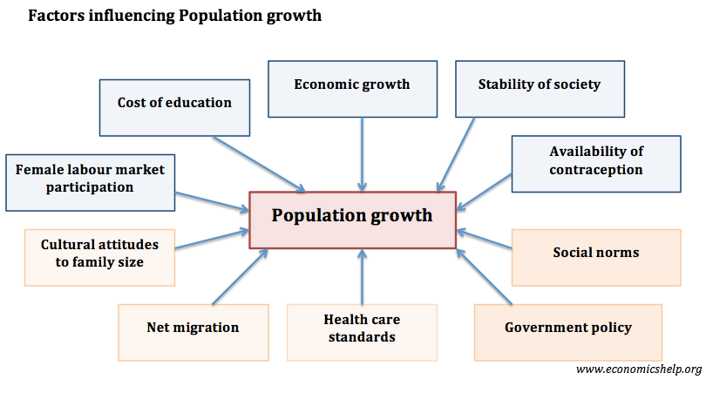
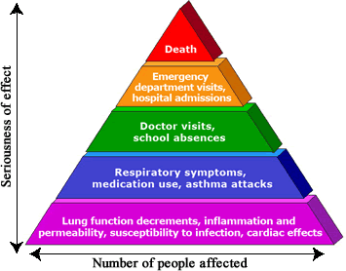

disaster if we don’t use them properly. Thi

